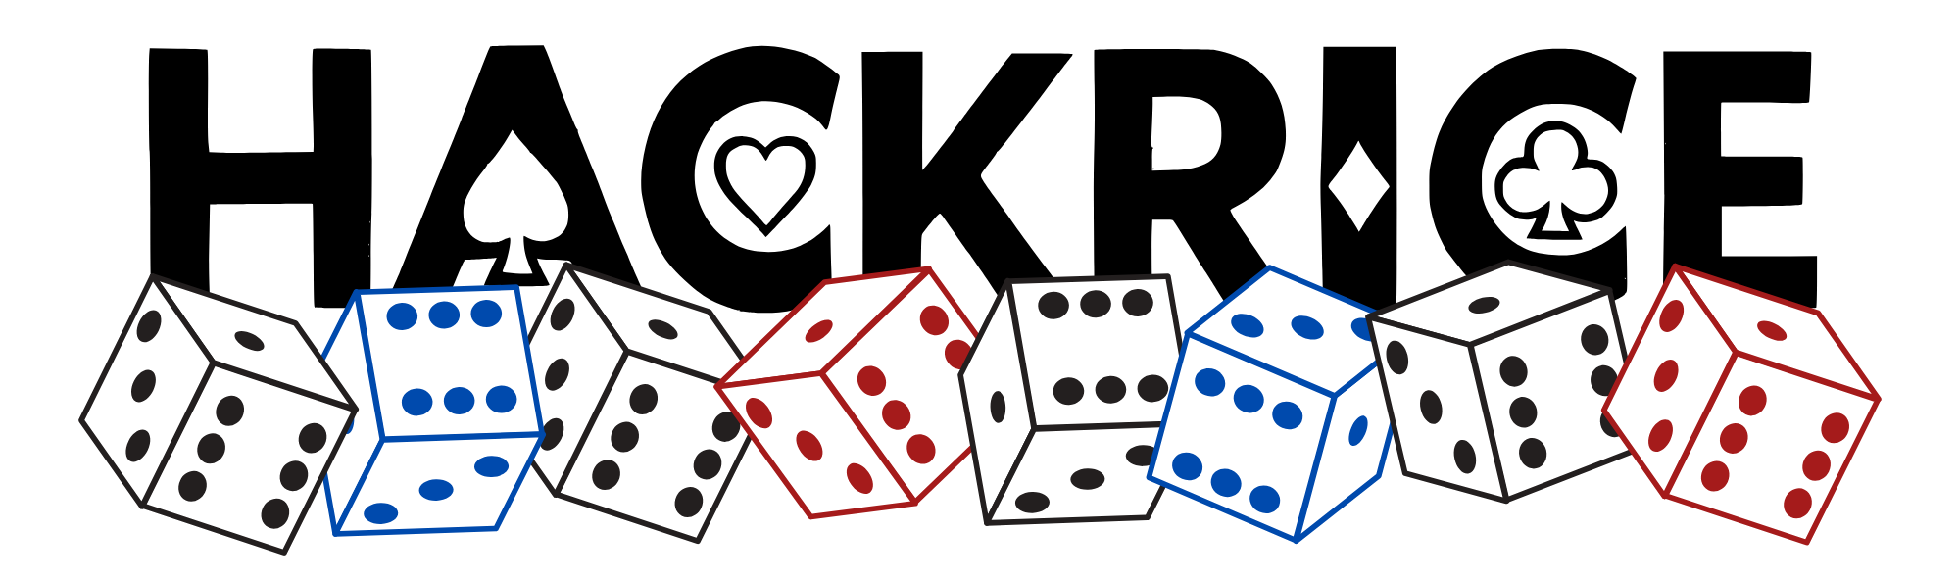

HR16 Hacker Handbook
WIP pls be patient!

Table of Contents 2
Welcome! 3
Schedule 4
FAQ 6
Workshops 7
Mathworks Workshop – Saturday @ 9:30 am
Persona Workshop – Saturday @ 2:15 pm
MLH Intro to Google AI Studio Workshop – Saturday @ 3:30 pm
MLH Hacking with GitHub Copilot Workshop – Saturday @ 4:15 pm
MLH Tech Together Meetup – Saturday @ 5 pm
Sponsors and Challenges 9
Partners 14
Prizes and Tracks 18
Judging Guidelines 22
Submission Guidelines 23
The HackRice 16 Board 24
Venue Setup 26
Getting to Rice 28
Checking in Late? 29
Overnight Accommodations 29
Resources 30

Welcome!

Welcome to HackRice 16! We’re so excited that you’re here!

This handbook contains all of the information you’ll need for HackRice 16 (Rice University’s Annual Premier Hackathon for Undergraduate Students), from the event schedule, to tracks and sponsored challenges, to helpful resources, and where to find us! Please read this document in its entirety to get the most out of HackRice 16!!

Join our Discord for announcements and to interact with fellow hackers, sponsors, and mentors!

We’re looking forward to seeing what you come up with at HackRice 16!

Best,
The HackRice 16 Team

Schedule
Join our Discord for announcements and to interact with fellow hackers, sponsors, and mentors!

Key
** Mandatory
* Highly recommended

Note: all times are in CT. RMC Courtyard activities might change to RMC Sammy’s if it starts raining.

Friday
4:00-6:30 PM **Rice Student Check-In @ RMC Courtyard
4:15-6:30 PM **Non-Rice Student Check-In @ RMC Courtyard
4:30-6:30 PM *Company Career Fair @ Sammy’s
6:30-7:30 PM **Opening Ceremonies @ RMC Grand Hall
7:30 PM Dinner @ RMC Courtyard
7:30-8:00 PM Form teams & hang out @ RMC Grand Hall or on Discord
8:00 PM Hacking officially begins!
8:30-9:30 PM Workshop: First Timers @ Farnsworth Pavilion
10:00 PM - 12 AM Casino Night Social @ RMC Grand Hall

Saturday
8:00 AM Breakfast @ RMC Courtyard
9:30-10:30 AM Workshop: Mathworks @ Keck Hall 100
11:30 AM Typing Tournament @ RMC Grand Hall
12:30 PM Lunch @ RMC Courtyard
2:15-3:15 PM Workshop: Persona @ Farnsworth Pavilion
3:30-4:00 PM Workshop: Intro to Google AI Studio @ Farnsworth Pavilion
4:15-4:45 PM Workshop: Hacking with GitHub Copilot @ Farnsworth Pavilion
5:00-6:00 PM Tech Together Meetups @ Farnsworth Pavilion
7:30 PM Dinner @ RMC Courtyard
9:00 PM *BobaTalks Social @ Farnsworth Pavilion

Sunday
8:00 AM Breakfast @ RMC Courtyard
8:45 AM **15-minute warning! Make sure to submit your project @ Devpost
9:00 AM ** Hacking officially ends!
9:30 AM-12:00 PM **Judging
12:00-1:00 PM Lunch @ RMC Courtyard
2:00-2:30 PM *Top 5 Live Presentation @ RMC Grand Hall
3:00-3:30 PM *Closing Ceremony + Awards @ RMC Grand Hall



24/7
HackRice Team @ RMC and Discord

FAQ

Where do I go to participate in the workshops, talks, raffles, and activities/mini-events?
Unless otherwise noted on the Schedule, all workshops, talks, raffles, and activities/mini-events will be held in the RMC Grand Hall!

Where can I find the HackRice team if I need help?
A HackRice team member will always be available on Discord to help and answer any questions. You can also find us in RMC wearing navy or maroon quarterzips throughout the day!

Where can I find the mentors?
You can find mentors throughout the RMC Grand Hall or on Discord!

Workshops

First Timers Workshop - Friday @ 8:30 pm (Farnsworth Pavilion)
Join us for the First Timers Workshop! Begin with an overview of the development process, from concept to creation. Learn how to build an effective team, plan your technical approach, and design fullstack apps! Perfect for beginners and aspiring developers eager to turn their ideas into reality!

MathWorks Workshop - Saturday @ 9:30 am (Keck Hall 100)
Agentic Engineering: When AI Stops Suggesting and Starts Doing
What if an AI teammate could turn your idea into working, tested engineering results? This session introduces agentic AI and demonstrates how coding agents can use MATLAB and Simulink to write code, build models, run simulations, diagnose errors, and verify outcomes. Through a live lung-ventilator modeling demo, students will see how natural-language intent becomes an actionable data analysis and modeling workflow. Learn how agentic tools can accelerate hackathon development, while keeping creativity, engineering judgment, and accountability firmly in your hands.

Persona Workshop - Saturday @ 2:15 pm (Farnsworth Pavilion)
Persona's Resume & Interview Prep Workshop
Your resume is your first impression—make it count. In Persona's Resume and Interview prep workshop, we’ll cover how to highlight your skills, projects, and experiences so they stand out to employers. Along the way, I’ll also share practical tips for interview prep and how to tell your story with confidence.

MLH - Intro to Google AI Studio Workshop - Saturday @ 3:30 pm (Farnsworth Pavilion)
Google AI Studio is the fastest way to start building with the Gemini family of multimodal generative AI models. Google AI Studio allows you to try out Gemini's massive token context window, grab an API key in seconds, and experiment out prebuilt prompts.

MLH - Hacking with GitHub Copilot Workshop - Saturday @ 4:15 pm (Farnsworth Pavilion)
Learning to use AI throughout your development flow is now an essential skill. GitHub Copilot is a fully-agentic AI pair programmer that can help you write, debug, & understand code. Today we’re learning by doing. We'll fork a README for your personal GitHub profile. We'll then use the GitHub and MLH MCP servers to pull live, personalized data. GitHub Copilot will use the template and data to create a customized profile just for you.

MLH - Tech Together Meetups - Saturday @ 5:00 pm (Farnsworth Pavilion)
The meetups will provide attendees with opportunities to connect, share ideas, and discuss industry challenges at the hackathon. We aim to enhance the overall hackathon experience and promote an inclusive atmosphere. These meetups will be targeted to underrepresented gender participants and their allies at hackathons.

Sponsors and Challenges
(We are still receiving finalized details from our sponsors. This section will be updated as they come in.)


Rice Computer Science Department
Background: Established in 1984, the Rice University Computer Science Department is renowned for its cutting-edge research and educational excellence. With a strong focus on areas like artificial intelligence, data science, and cybersecurity, it plays a pivotal role in advancing technology and fostering innovation. The department's contributions extend beyond academia, impacting industry and research communities, making it a vital hub for technological advancement and knowledge dissemination.


Goldman Sachs
Background: Goldman Sachs is a leading global financial institution that provides investment banking, securities, and asset management services to clients worldwide. With a history spanning over 150 years, Goldman Sachs is known for leveraging technology to solve complex financial challenges, from risk management to trading systems and fintech innovations. The firm actively supports initiatives at the intersection of finance and technology, encouraging the next generation of innovators to design solutions that advance financial inclusion, sustainability, and economic growth.

Goldman Sachs will be offering a challenge this year, more details to come soon!


Persona
Background: Persona Identities, Inc. (Persona) offers a unified identity platform that offers organizations the building blocks they need to securely collect, verify, manage, and make decisions about individuals’ and businesses’ identities — along with automation and orchestration tools to streamline the entire process from end to end. Founded in 2018, Persona is headquartered in San Francisco and is available in 200+ countries and territories and 20 different languages. Persona serves any organization that needs to verify the real identities of people or businesses, including retail, fintech, marketplace, delivery services, real estate and hospitality, HR, edtech, legal services, home and childcare services, and more.

Persona Challenge: Prove you're human
The internet is filling up with bots, generated faces, and accounts nobody is actually behind. Every app you use is asking the same question somewhere in its backend: is there a real person on the other side? Build something where access depends on a verified human, and make it feel good. Anyone can bolt a checkpoint onto a signup form. Make one people don't mind going through. Setup runs about 10 minutes. Persona is the identity platform behind Roblox, OpenAI, Coursera, and Instacart. Sign up free, grab a sandbox key, drop our web widget into your project. That's ten lines of JavaScript, or zero if you use a hosted link. There are iOS, Android, and React Native SDKs, plus webhooks and a no-code Workflows builder if you want to go further. Everything runs in sandbox, so it's free and no real IDs are involved. A toggle forces a pass or a fail, so you can demo every path your app takes. Come find our table. We brought engineers and we'd rather debug with you than watch you struggle.

Some directions:
- A campus marketplace, sublet board, or ticket resale where both sides are verified before money moves.
- A community platform that actually enforces one person, one account.
- Something age-aware that adapts to the user instead of demanding a full ID from everyone.
- An AI agent that can only act for you once you've proven you're you.
- Anything else where trust between strangers is the hard part.


Capital One
Background: More than 25 years ago, Capital One revolutionized the credit card industry with data and technology. Today, we are one of the most widely recognized brands in banking — serving more than 100 million customers across a diverse set of businesses.
Challenge: Best Use of Nessie
Capital One challenges you to reimagine the banking experience by building an innovative application that leverages the Nessie API. Featuring access to mock financial data including accounts, merchants, bills, and peer-to-peer transactions, Nessie is your sandbox for solving real-world financial problems. We want to see projects that creatively integrate Nessie’s endpoints to empower users and improve their financial lives.
Prizes: $250 Giftogram Gift Cards (Per Member)

Lilie Lab
Background: Description for LILIE: “The Liu Idea Lab for Innovation and Entrepreneurship (Lilie) is the home of experiential learning and co-curricular activities in entrepreneurship and innovation at Rice University. Our mission is to equip Rice students with both entrepreneurial skills and the entrepreneurial mindset to prepare them to be entrepreneurs and innovators in whatever industry they choose, be it a technology startup, government, civic group, non-profit, small business, or large corporation.
Challenge: Lilie Lab AI Challenge [RICE ONLY]: Build applications, tools, or platforms that utilize Artificial Intelligence in some way to solve a pressing problem in the world. The tool can meet a social need, streamline an area of your life, make a new game, or revolution an entire industry – combine your passion with AI and blow our minds!
Prize: $50 Amazon Gift Cards, Immediate Launchpad Acceptance to Launch Group 1 (~$100 in non-dilutive grant funding).


Ken Kennedy Institute
Background: The Ken Kennedy Institute at Rice University fosters world-class foundational and use-inspired research in AI and Computing and enables its transformative use across diverse disciplines to solve global challenges, driven by the highest ethical principles. We aim to position Rice at the forefront of Responsible AI with an emphasis on health, urban communities, and resilient futures. Learn more about our research areas at kenkennedy.rice.edu.


Rice Engineering Alumni
Background: Founded in 1938, Rice Engineering Alumni (REA) is the university’s oldest alumni affinity group, dedicated to supporting the George R. Brown School of Engineering. Each year, REA provides over $150,000 in scholarships and awards to exceptional students, offers opportunities for valuable internships, and fosters connections between alumni and current students. Through initiatives like the Oshman Engineering Design Kitchen, Rice Center for Engineering Leadership, and OwlSpark, REA plays a key role in nurturing the next generation of engineers and supporting their academic and professional growth.


Notability
Background: Notability is a popular multimedia note-taking and PDF-annotation application designed primarily for Apple platforms like the iPad, iPhone, and Mac.
Notability is offering a "Trust the Process" Challenge where attendees build with Notability Pro during the hackathon. Recommended uses: ideation, brainstorming, discussion summaries, wireframing, etc. The best use of Notability wins a prize! Notability will provide an early access promo code so that you can get acclimated with the app (available on iOS, Android, and Web) with one free month of Notability Pro. We will present this promo code during opening ceremony and the code will be capped at 500 redemptions!

Partners


Nord Security
Background: Nord Security is a global cybersecurity leader dedicated to providing robust online privacy and security solutions. With a mission to make the internet safer for everyone, Nord Security offers a suite of cutting-edge products, including NordVPN, NordPass, and Incogni. These tools encompass virtual private network services, secure password management, and file encryption, respectively. Trusted by millions of users worldwide, Nord Security's commitment to user-centric, privacy-first technology underscores its pivotal role in safeguarding digital freedoms and protecting online data from potential threats.


BobaTalks
Background: BobaTalks connects students with mentors, resources, and community to overcome career and personal challenges. Whether switching careers, interning, starting your first job, or seeking guidance, you’re never alone.


Jeni’s IceCream
Background: Founded with a passion for creativity and community, Jenny’s Ice Cream is more than just a dessert brand—it’s an experience. Known for bold flavors, high-quality ingredients, and a dedication to sustainability, Jenny’s brings people together through shared joy. From locally inspired creations to nationwide favorites, the company celebrates craftsmanship, inclusivity, and the simple delight of ice cream done right.

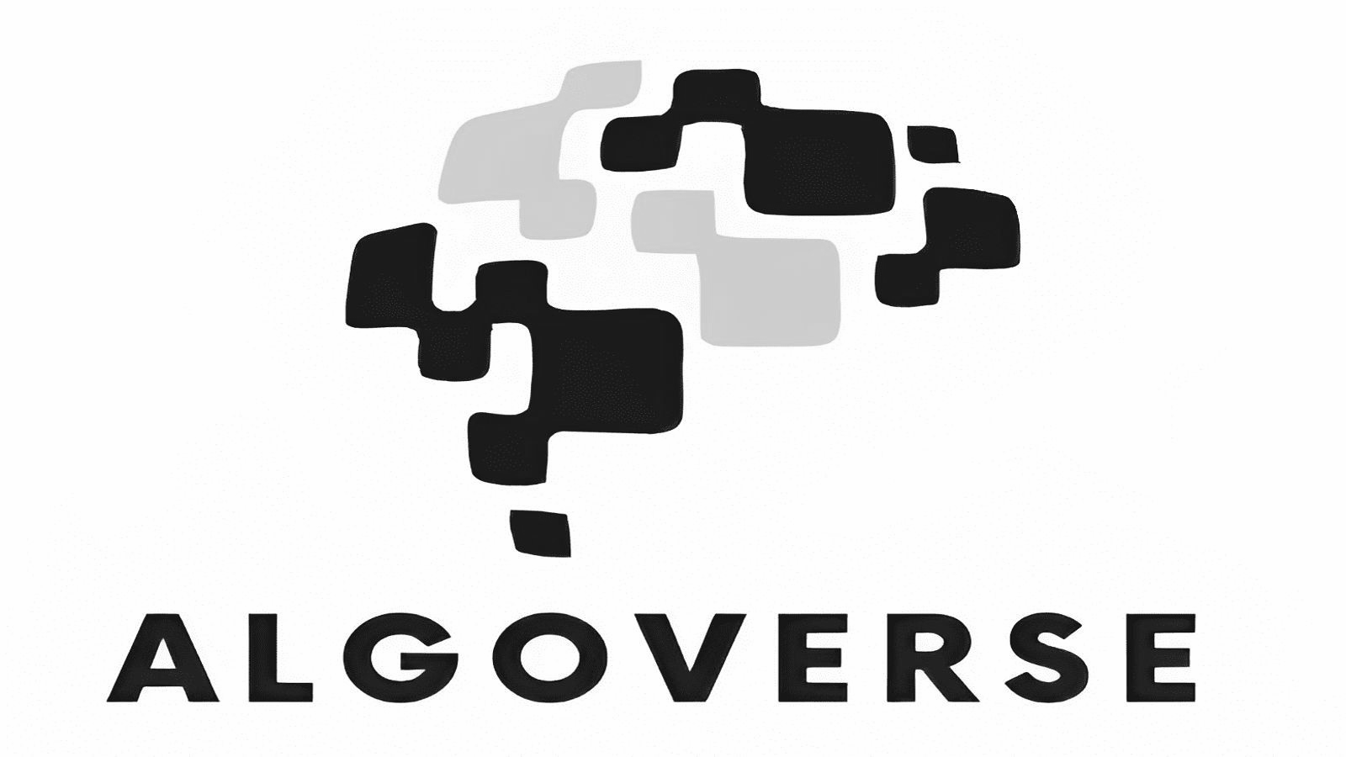
Algoverse AI Research
Background: Algoverse is offering a program discount for you all, 15% for everyone and 30% for our winners, for their AI research program where high school and college students work alongside researchers and industry professionals from leading universities and AI labs to produce original research for submission to top AI conferences, including NeurIPS, ICLR, AAAI, ACL, and CVPR.


Mathworks
Background: MathWorks is an American software development company that specializes in mathematical computing software for engineers and scientists.

The Best Use of MathWorks prize will be offered this year! Use MathWorks tools for the bulk of the project, it can be a part of the healthcare track. Base the final product on an in Silico Medicine physical model from our documentation or created by the participating team. Develop a solution to a real problem. Using agentic Al with the MATLAB & Simulink agentic toolkits is optional. Check out more here!
​​


Lovable
Background: Lovable is an AI-powered software development platform that lets users build full-stack web applications and websites just by chatting in plain English. Lovable wil be offering credits this year! Each participant who redeems it gets the Pro plan benefit for one month from redemption. It can’t be redeemed on an existing paid workspace, but attendees can create a new workspace on their existing Lovable account to use it.


ElevenLabs
Background: ElevenLabs is a global leader in voice AI research and audio generation technology. The company develops advanced, context-aware AI models that create ultra-realistic, emotionally expressive synthetic voices, sound effects, and multilingual audio. Driven by a mission to make content universally accessible in any language and voice, ElevenLabs bridges the gap between digital content and human-like auditory experiences.
All participants get 1 month free of our Creator tier (normally $22/month, 131k credits). For the overall winning team, each team member receives 3 months of our Pro tier ($297 value/team member, 600k credits/mo).
ElevenLabs is offering the following challenge: Best Project Built with ElevenLabs: Each team member receives 3 months of our Scale tier ($897 value/team member, 1.8M credits/mo)
For distribution, all participants (that were sent final confirmation emails ONLY) can claim their free ElevenLabs access through our automated Discord system:
- Join the Discord server: https://discord.com/invite/VnBvbbcdEC
- Gain access to the #🎟️│coupon-codes channel
- Click "Start Redemption"
- Select the event and fill out the form using the email used for registration
- The bot sends the unique coupon code
- Video Tutorial: https://youtu.be/S143_JtCtV8


MLH
Background: MLH is the official student hackathon league. Each year, we power over 200 weekend-long invention competitions that inspire innovation, cultivate communities and teach computer science skills to more than 65,000 students around the world. MLH is an engaged and passionate maker community, consisting of the next generation of technology leaders and entrepreneurs.
MLH has EIGHT (8) prize tracks this weekend, check them all out at this link!
MLH will also have a hardware lab. The contents may vary, but you can find a rough idea of the contents here!

Prizes and Tracks
Overall Prizes
First: Ruko Drone, Second: Kodak PixPro Digital Camera, Third: Whoop Fitness Tracker
Healthcare Track
Longevity has become one of the biggest trends in healthcare. For years, the focus was simply on lifespan, but the real goal now is healthspan—not just living longer, but staying healthy for more of that life. Longevity isn't a single problem to solve; it's a stack of layers that build on one another. At the base is molecular and cellular aging—cellular senescence, inflammation, DNA damage. On top of that sit biomarkers and diagnostics, which let us track biological age. Above those are the everyday lifestyle factors: sleep, nutrition, exercise, and stress, and at the outermost layer, environment and social connection. Every layer shapes how long someone actually stays healthy.
This track invites you to design and prototype a user-facing application that ties these layers together, turning complex science into clear, actionable guidance that helps people understand their biological age and take real steps to extend their healthspan.

Example directions
- Health and wellness tracking powered by personal health and lifestyle data.
- Personalized recommendations to support healthier habits and long-term well-being.
- Educational insights that make complex health and longevity concepts easy to understand.
- Goal-setting and coaching tools that help users build sustainable healthy behaviors.

Example projects
- FAIR — personal air-quality guardian; covers the environment layer of the longevity stack (HackRice 15)
- DocuLabubu — assistant that helps you remember and understand doctor visits (HackRice 15)
Prize: Air Fryer

Finance Track
Managing money is something almost everyone struggles with, yet most people lack tools that actually fit how they live and spend. The Finance track challenges you to build personal wealth management solutions—budgeting, money tracking, and planning tools that help people understand their finances and make better decisions.
Create an app or website that helps individuals take control of their money. The best projects don't just display numbers; they turn raw financial data into personalized, actionable insight, meeting people where they are and helping them build healthier financial habits over time.

Example directions
- Budgeting and expense tracking that categorizes spending automatically and surfaces where the money actually goes.
- Personalized insights and recommendations—spotting trends, flagging overspending, and suggesting realistic ways to save.
- Goal-based planning for things like an emergency fund, a big purchase, paying down debt, or saving for the future.
- Smart money tools such as bill reminders, subscription tracking, or simple forecasting of cash flow.

Example Projects
- OwlNudge — timely nudges from your spending that save money and prevent fees (HackRice 15)
- Swipe Coach — links your cards, tracks spending, and tells you which card maximizes cashback per purchase, plus monthly insights (HackRice 15)
Prize: Espresso Machine

Games & Gamification Track
Play is one of the most powerful tools we have for learning, motivation, and connection. This track challenges you to build something genuinely fun — a game in its own right, or an experience that uses game mechanics to make a hard or boring task feel rewarding.
Build a game, or apply gamification to a real problem. Whether you create an original game from scratch or layer points, progression, challenges, and rewards onto an everyday task, your goal is to design an experience people actually want to come back to.
Teams with a theme-related submission will win a SURPRISE!

Example directions
- An original game — web, mobile, or desktop — in any genre.
- Gamified learning that turns a subject or skill into a game loop.
- Habit-building or wellness apps that use streaks, quests, and rewards to drive healthy behavior.
- Social or multiplayer experiences that bring people together.
- Adding creative features to existing games.

Example Projects
- CodeMafia — "Among Us meets competitive programming," a real-time multiplayer browser game where developers fix bugs while an impostor sabotages; strong on fun factor and polish
- GenEngine — turns plain-English prompts into playable games (HackRice 15)
- GameToLearn AI(G2L AI) — turns any file into interactive learning games (HackRice 15)
Prize: Professional Poker Set

Work & Productivity Track
From task overload to digital distractions, staying productive can feel harder than ever. This track challenges you to design a solution that helps individuals or teams work smarter, not harder.
The possibilities are wide open: build a tool for students juggling assignments, teams collaborating remotely, or educators teaching multiple classes. The best part — you can create something that helps you, and walk away from this hackathon with a solution you'll keep using. Focus on supporting healthy habits, reducing cognitive overload, and making work and learning feel manageable (and maybe even enjoyable).

Example directions
- Task and project management built around how people actually work.
- Focus, attention, and distraction-management tools.
- Collaboration tools for remote or hybrid teams.
- Learning and classroom tools for students and educators.

What judges look for
- A real productivity pain point, clearly understood.
- A design that reduces friction rather than adding it.
- Something you'd genuinely keep using after the event.

Example Projects
- HootHive — turns recorded lectures into structured, collaborative study resources; fits the learning/classroom direction (HackRice 15)
- Agent Evan — a desktop agent that takes action across apps to automate tasks (HackRice 15)
- TouchGrass — proactively prevents software engineers from burning out; a focus/wellbeing angle on productivity (HackRice 15)
Prize: Mini Projector

Judging Guidelines
Technical Rigor
We are looking for technically advanced solutions to technically challenging problems that make use of hardware and/or APIs. However, making an extensive solution with integrated simple technologies is equally impressive!

Originality & Creativity
We are looking for original ideas or new angles on existing ideas. For example, using an API in a unique way. We know APIs work—we want to see if you can do something new and awesome with them!

User Experience & Design
We are looking for aesthetically pleasing projects with a clear and intuitive user experience.

Practicality & Impact
We are looking for impactful projects that solve real-world problems. Additionally, we would like to emphasize the importance of the scope of your project as well as the scalability of your solution.

Relevance
If you submit your project to a track or challenge, we are looking for relevance to the spirit/requirements of that track/challenge.

Submission Guidelines
Devpost Submission

Prior to the Devpost submission deadline (Sunday 9/13, 9:00 am), submit a 3-4 minute video to Devpost. THIS IS MANDATORY! We have included a recommended outline for your video submission. Be sure to choose at most 1 track, yet you can choose multiple challenges.

30 seconds Intro
Project name, members, track/challenge, project purpose, technologies used

2 minutes Demo
Let’s see your project in action!

30 seconds Technical design and implementation
High-level overview of how you designed your code

30 seconds Impact
The real-world value of your project; how you’d improve it in the future

Live Judging Rules!

We will be doing live judging for HackRice 16! This means that you will present your project live 3-4 times to judges during the live judging period on Sunday from 9:30 AM - 12 PM. Judging will be 3 minutes total, 2 minutes for the demo, and 1 minute for Q&A at the end.

The HackRice 16 Board

  Hazel Goetsch  Co-Director  Senior, Martel College |   Jacob King  Co-Director  Junior, Duncan College |   Varshini Loganathan  Co-Director  Junior, Duncan College

  Sophia Chen  Tracks & Workshops  Sophomore, Hanszen College |   Oscar Pan  Tracks & Workshops  Junior, McMurtry College | 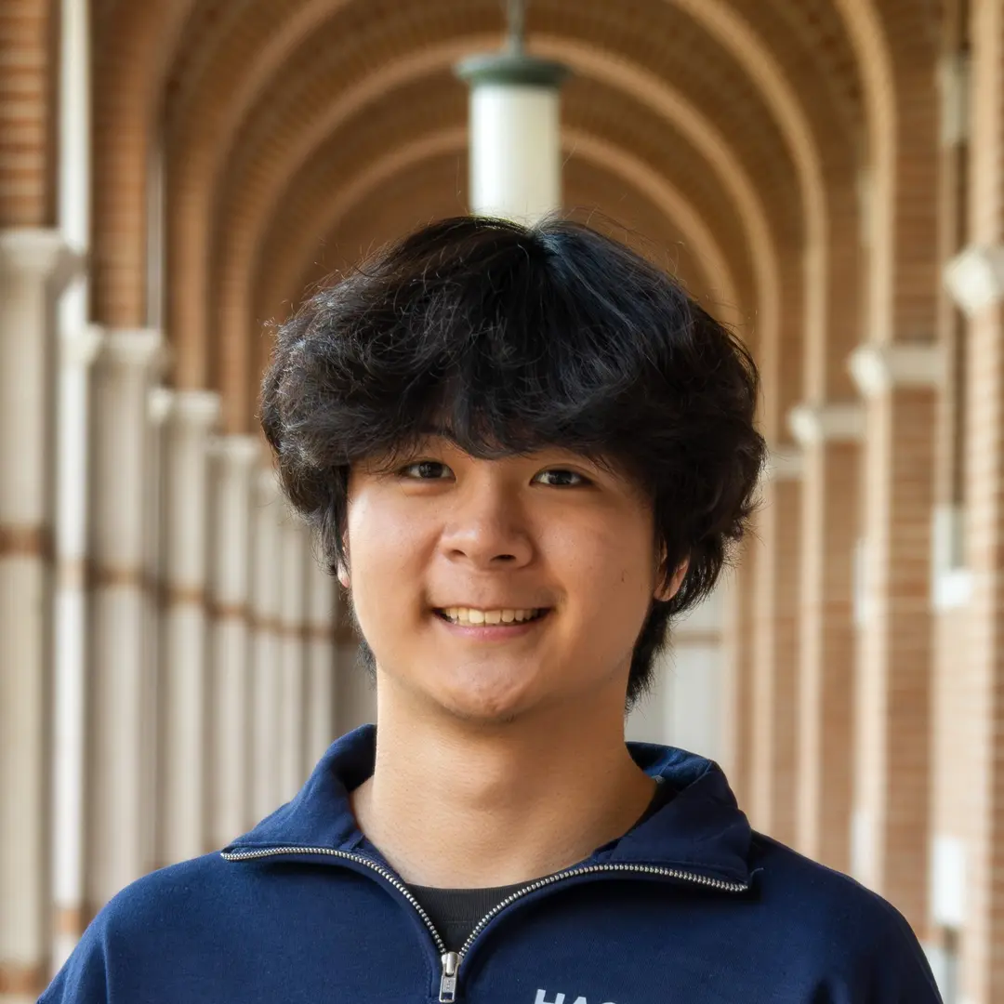  Henry Shan  Tracks & Workshops  Sophomore, Sid Rich College
  Sanjana Dabbiru  Design  Junior, Hanszen College | 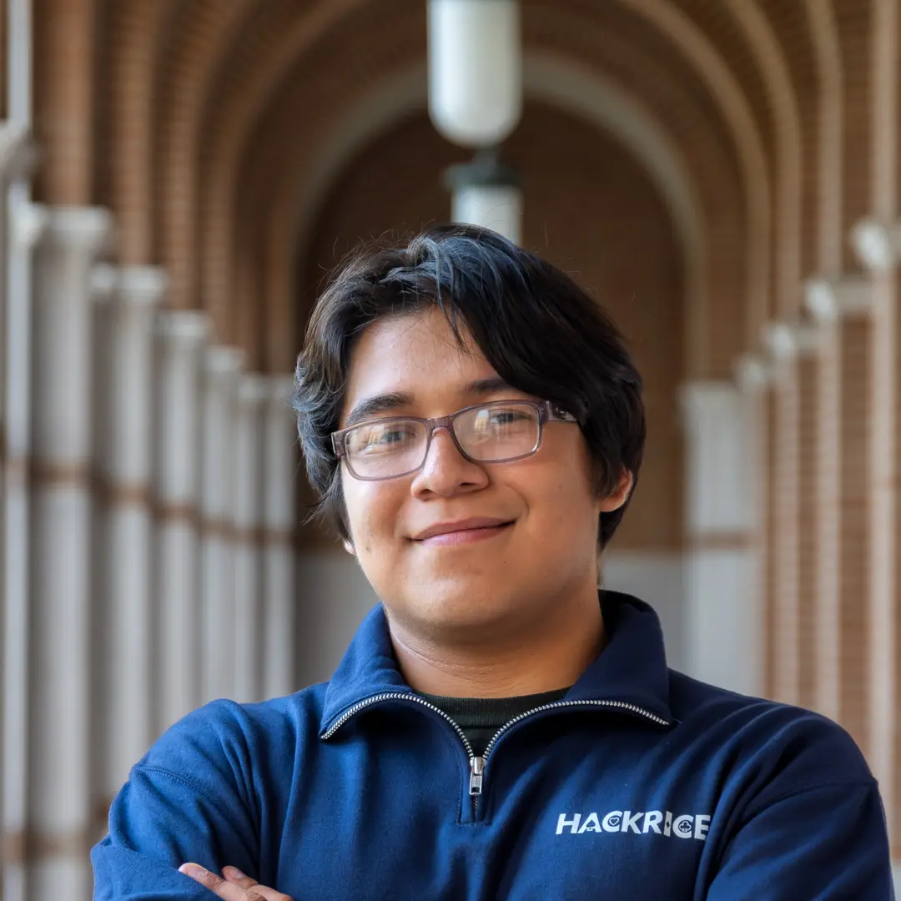  Tony Martinez  Design  Senior, DuncanCollege |   Steve Zhang  Design  Sophomore, Wiess College

  Abena Poku  Logistics  Sophomore, Sid Rich College |   Saanvi Mukkara  Logistics  Junior, McMurtry College

  Milan Cohen Camarena  Public Relations  Sophomore, Baker College |   Jacqueline Chung  Industry Outreach  Junior, Jones College

Venue Setup
All events take place in the Rice Memorial Center. If you need to talk to an organizer, find us in the Meyer Conference Room.

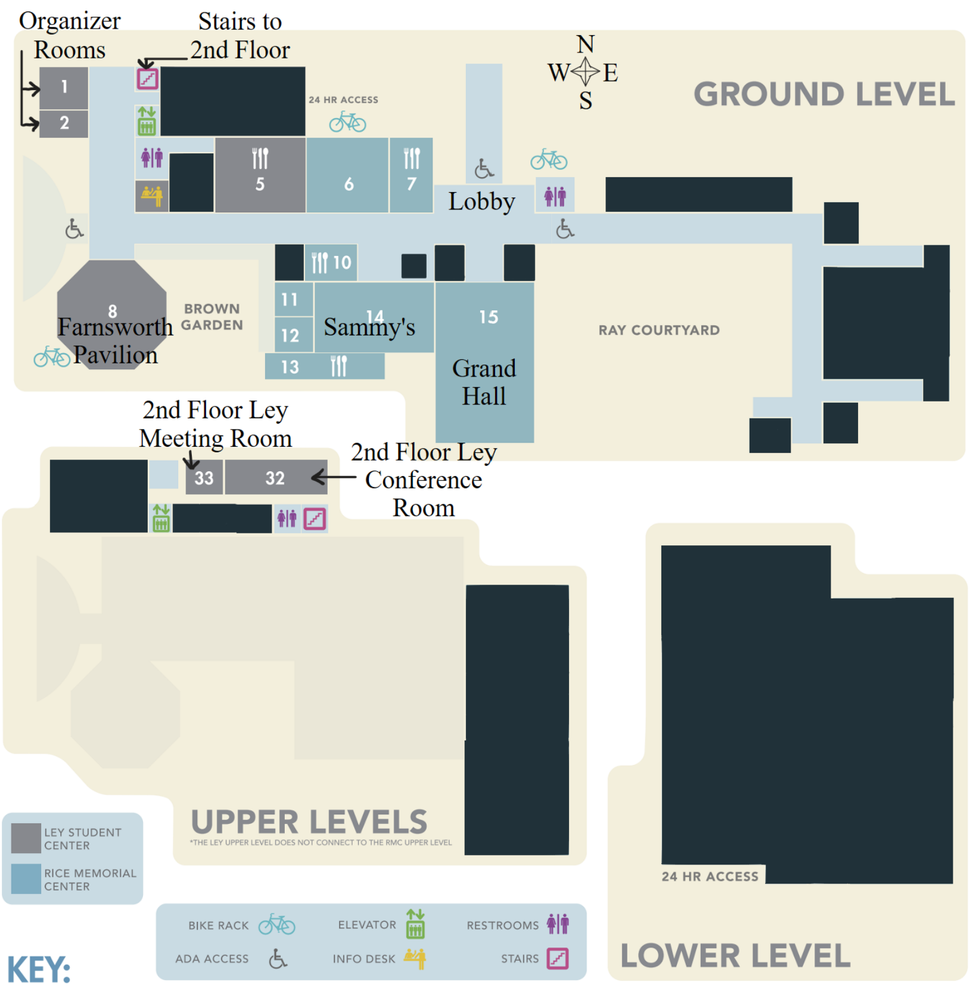

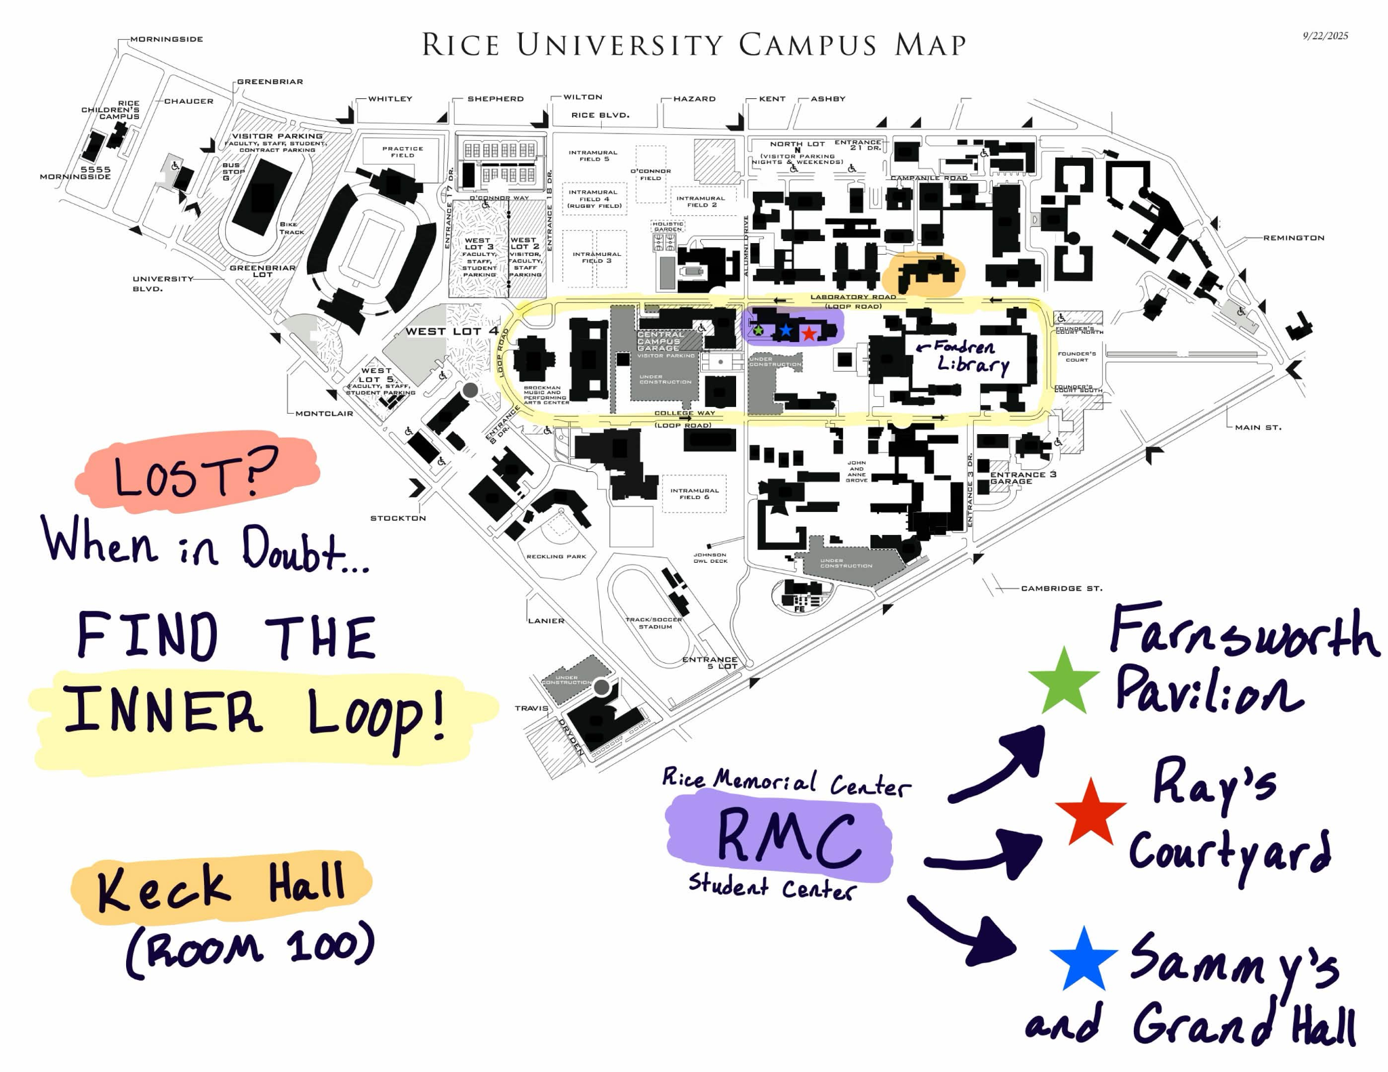
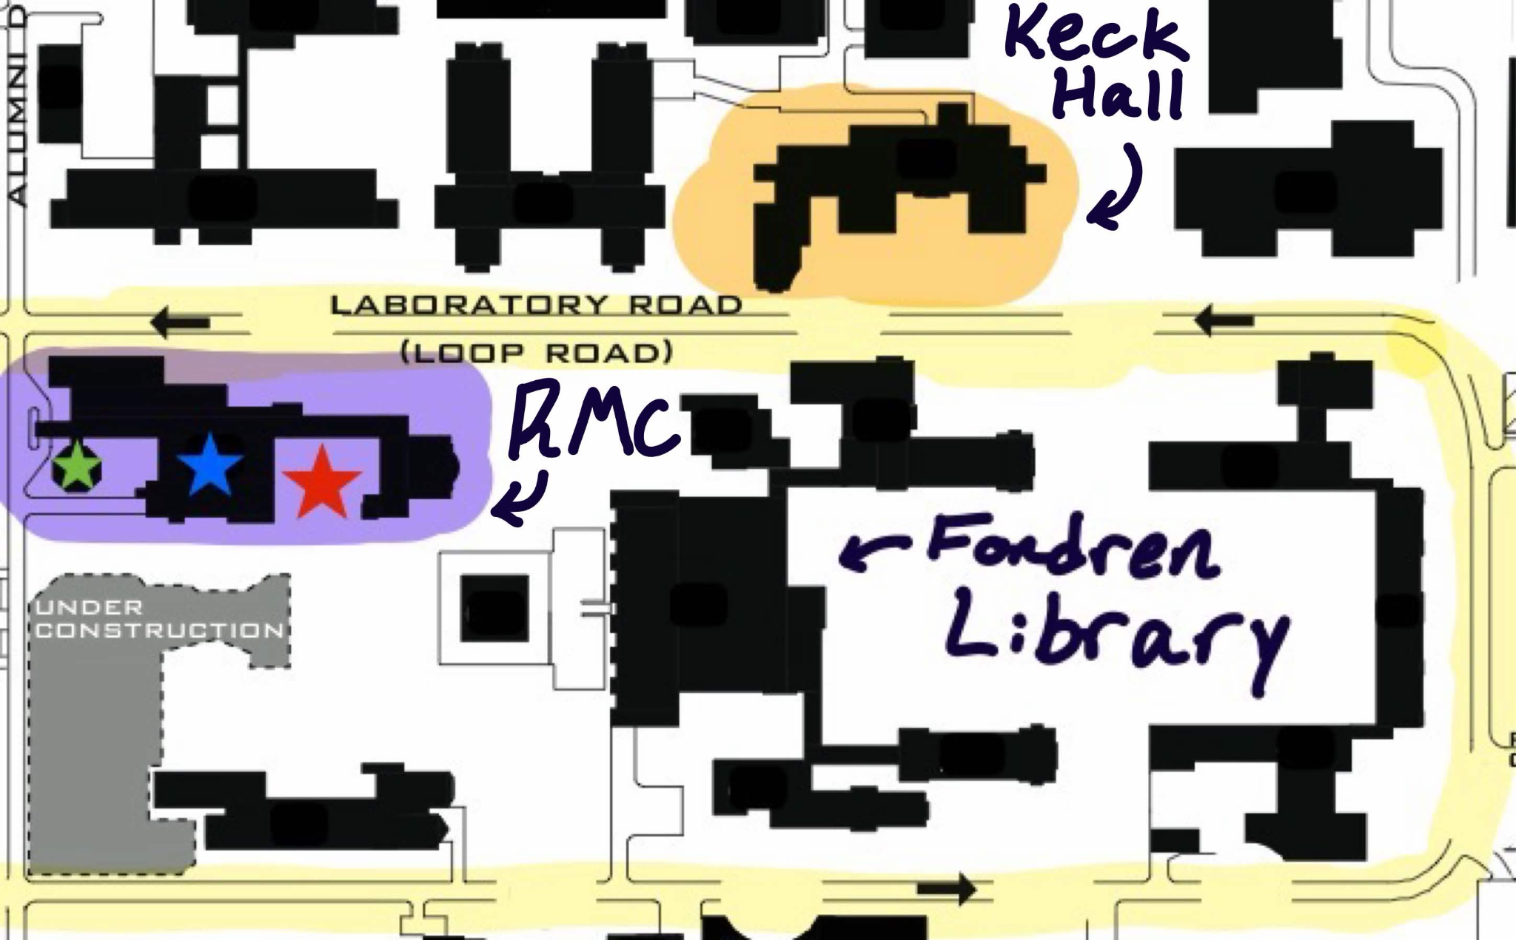

Getting to Rice
For general driving information on getting to Rice from Bush or Hobby airports, see https://www.rice.edu/get-to-rice.

There are two major public transportation routes from Hobby to Rice:

- From Hobby, take Bus Route 73 Fannin South TC to Fannin South Pr, then transfer to the Red Line - North Line TC to Hermann Park / Rice U Station. ~1hr, $1.25.
- From Hobby, take Bus Route 500 Downtown Direct to St Joseph Pkwy @ Main St, then transfer to the Red Line - Fannin South to Hermann Park / Rice U Station. ~50 min, $5.75.

There are two major public transportation routes from Bush to Rice:

- From Bush, take Bus Route 102 Downtown to Pierce St @ Travis St, then transfer to the Red Line - Fannin South to Hermann Park / Rice U Station. ~1hr30, $1.25.
- From Bush, take Bus Route 500 Downtown Direct to Travis St @ St Joseph Pkwy, then transfer to the Red Line - Fannin South to Hermann Park / Rice U Station. ~1hr20, $1.25.

Check Google Maps for more detailed instructions and bus schedules.

Checking in Late?
Fill out this form! Otherwise, we may give your spot away to a walk-in after the opening ceremony. If you already told us on your FINAL confirmation form that you were planning on coming in late, then we have you marked down. To be extra safe though, we’d absolutely appreciate it if you took 2 minutes to fill out our quick form!

Parking Info
- Parking passes are first-come first-served - ask a director for one during check-in
  - Parking passes are valid at nearby Central Garage or North Lot
  - Otherwise, the best price is Greenbriar Lot for $4 daily
- To use the parking pass, place a valid card into the machine to get in. Once you are leaving, FIRST, place the parking validation pass into the machine. SECOND, insert the same valid card to exit.
- Parking passes are DAY passes only and they are valid for 24 hours from the time you first parked. To get your second parking pass after your first parking pass expires, remove your car within 24 hours of when you first parked today. Insert your parking pass when exiting. Pay with the same credit card you used originally. Re-park your car in the lot. Send us a photo of you inserting the parking pass when leaving. After we receive your photo, we’ll give you one more pass that will cover you until Sunday.
- These vouchers are one-time, 24-hour passes. Once used, they cannot be reused. If you don’t follow these steps exactly, we cannot reimburse you, and your card will be charged.
  - They are only valid for 24 hours. If you try using them past 24 hours, your card will be charged and there will be nothing we can do.

Overnight Accommodations
Fawnsworth Pavilion (marked on the map, where all of the workshops are during the day) will serve as a dedicated sleeping area overnight. Bring your own sleeping materials (sleeping bag, pillows, etc.). Fawnsworth Pavilion must be vacated during the day as workshops will be hosted here. This includes removing any personal belongings.

Shower Resources
1. Gibbs Recreation & Wellness Center (on campus)
- Day pass: $7, but only for Rice students/faculty/staff
- Guest pass: $12, but requires an existing Rice member to sponsor the guest in person at the Operations Desk
- Cash/check only (no cards); admin office sells passes M–F 8:30am–4:30pm, or pay at the Operations Desk directly
- https://recreation.rice.edu/memberships/guest-pass

2. 24 Hour Fitness – Houston Rice Village Super-Sport (off-campus)
- 2500 Dunstan Rd, Houston, TX 77005, right in Rice Village, roughly a 10–15 min walk from most of campus
- Open 24/7, good for overnight hackers
- Has pool, sauna, and steam room in addition to standard locker/showers
- Day/guest passes at 24 Hour Fitness generally run $10–20 and some locations offer a free first visit, but it varies by club, so call ahead: (713) 662-3481
- https://www.24hourfitness.com/gyms/houston-tx/houston-rice-village-super-sport
- https://24hourfitnessmembership.com/24-hour-fitness-day-pass/
3. Weekley Family YMCA (free, but not walkable)
- 7101 Stella Link Rd, Houston, TX 77025 — roughly 2.5–3 miles from campus, so this is a bike/bus trip
- Free one-day guest pass (up to 3 per person per year), photo ID required, includes wellness floor and showers
- https://ymcahouston.org/join/guest-pass
Unfortunately, there aren’t any Planet Fitness, LA Fitness, or Anytime Fitness actually close to campus. The nearest ones are 2.5+ miles out in other neighborhoods. Boutique studios in Rice Village (Orangetheory, F45, Pure Barre) exist nearby, but they're class-based drop-ins rather than plain shower access, so a worse fit.

Meals
Friday Dinner — Mikki’s Cafe
- Spaghetti
- Fettuccine
- Fried Chicken
- Mac & Cheese
- Green Beans
- Cornbread Muffins
Friday Late Night — Tiff’s Treats
- Assorted Cookies
Saturday Lunch — Panda Express
- White Rice and Fried Rice
- Chow Mein
- Hot Orange Chicken and Kung Pao Chicken
- Beijing Beef
- Super Greens
Saturday Dinner — Tiger Noodle House
- Dry Fried Green Beans
- Veggie Rice Stir Fry Noodles
- Mapo Tofu
- Szechuan Spicy Chicken
- Spicy Cumin Beef and Mongolian Beef
- White Rice
Sunday Lunch — Zalat Pizza
- NYC Cheese Pizza
- NYC Margherita Pizza
- All-Beef Pepperoni Pizza
- Buffalo Chicken Pizza
- Gluten-Free Cheese Pizza
- Vegan Cheese Pizza

Resources
Discord is the one-stop shop for all HackRice 16 questions and announcements. Our team will be available on Discord, and so will sponsors and mentors if you have questions regarding challenges.

Helpful Links
Starter Code For Beginners
Opening Ceremony slides
First Timers' Workshop slides
Closing Ceremony slides
Discord
Website
Devpost

Web Development
React: https://reactjs.org/
React Native: https://reactnative.dev/
Node JS: https://nodejs.org/en/
MongoDB: https://www.mongodb.com/
Visual Studio Code: https://code.visualstudio.com/
Django: https://www.djangoproject.com/
Angular: https://angular.io/
NPM: https://www.npmjs.com/


